**// Subroutine : UpdateButtonClick_CUSOMTIZE_BOTTOMCUT()**

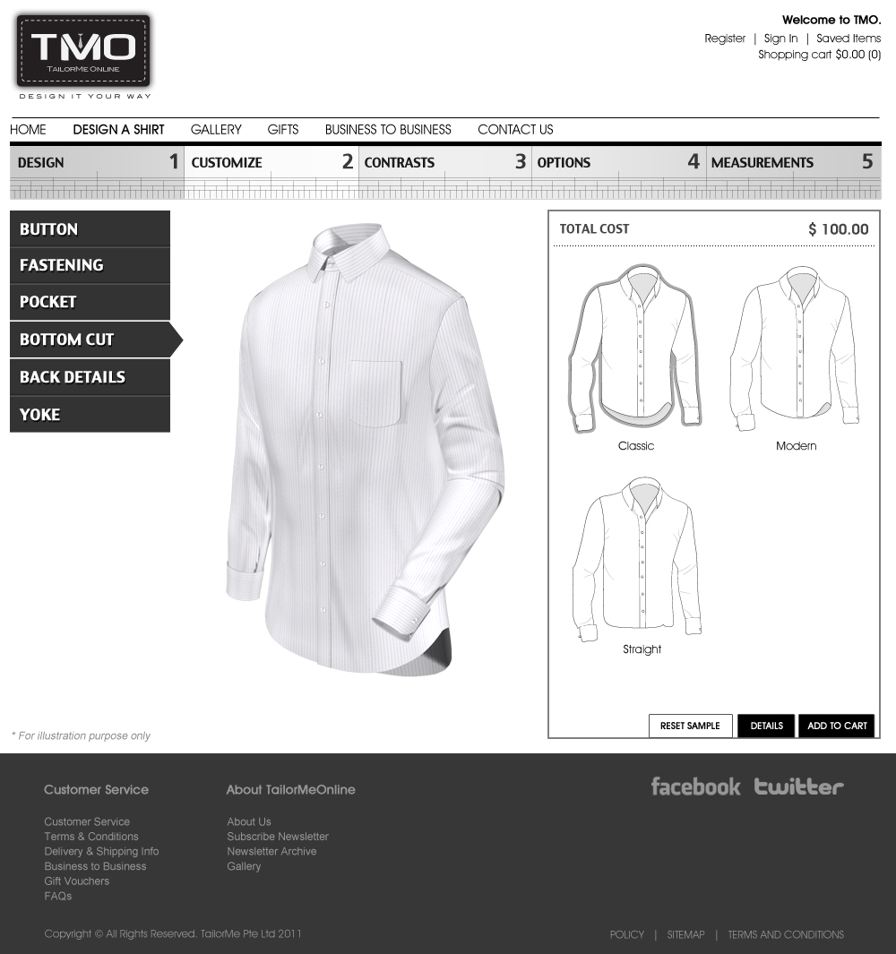

Upon clicking “Classic”:

ShirtLyr01[3] = “ClassicBot.”;

Call Subroutine : RefreshFilenames();

Call Subroutine : DisplayFullview(); // This updates the full shirt window

Upon clicking “Modern”:

ShirtLyr01[3] = “ModernBot.”;

Call Subroutine : RefreshFilenames();

Call Subroutine : DisplayFullview(); // This updates the full shirt window

Upon clicking “Straight”:

ShirtLyr01[3] = “StrBot.”;

Call Subroutine : RefreshFilenames();

Call Subroutine : DisplayFullview(); // This updates the full shirt window

**// End of Subroutine : UpdateButtonClick_CUSOMTIZE_ BOTTOMCUT()**